Week of December 21 - December 28, 2025
Opportunities for Worship, Service, Study, and Fellowship:

Today: Worship 10:45 am
Social time and Snacks after Worship
Monday: Canceled for this week
Tuesday:
Wednesday: WSAA Fellowship Hall 7:00 pm
Thursday:
Friday:
Saturday:
Sunday: Worship 10:45 am Social Time and Snack after Worship
______________________________________________________________________________
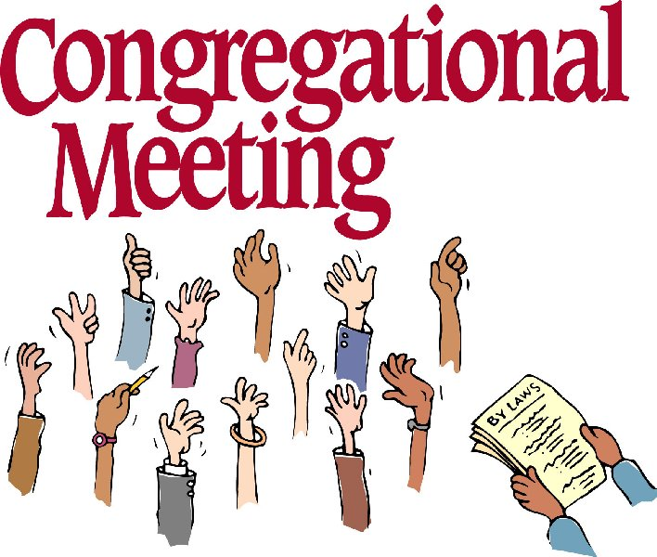
On January 11th we will have a congregational meeting to install the new elders, present end of year report and budget..

Murray Hill Presbyterian Church



Making His Purpose Count

940 Talbot Avenue
Jacksonville, Florida 32205
(904) 389-2939
www.mhpcjax.com
mhpcjax@gmail.com

Rev. Jesse Bozeman

December 21, 2025

December 21, 2025
Fourth Week of Advent

Gathering God’s People

Music for Gathering John Lansdale
Welcome and Announcements Samuel Bennett

*Call To Worship:

Leader: Behold! A teenage girl is pregnant with the God who knit her in her own mother’s womb,
People: strange signs from a strange God who upturns expectations.
Leader: She said yes to divine revolution even though it meant social condemnation.
People: strange signs from a strange God who upturns expectations.
Leader: God’s Spirit stokes subversive dreams in us to help us defy the status quo,
People: strange signs from a strange God who upturns expectations. Amen

Lighting of the Advent Candle of Joy

Lighting of the Advent Candle of Love

Leader: As we light our fourth Advent candle,
People: we rejoice with Mary, for Love has flesh.
Leader: Come now, O Child of Mary.
People: Come now, O Prince of Love.

*Song of Love: Love Lifted Me #508

Prayer of the Day

Immanuel, God with us, you folded your infinity into an infant’s body just to share in human life. Hold us as close as May, your mother, held you, safe and warm within herself. Whenever our bodies are used against us and we struggle to love our embodied selves, help us to feel your presence in our every cell making us sacred, exactly as we are.
(Observe a time of silence for personal prayers of confession) Amen

Passing the Peace of Christ:
Leader: May the Peace of Our Risen Christ be with you!
People: And also with you.
(It is our custom to greet one another at this time using the words above)

Song of Adoration (please find your way back to your seat as we sing together):
*Glory be to the Father, and to the Son and to the Holy Ghost, as it was in the beginning is now and ever shall be, World without end. Amen. Amen.

*Song of Joy: God Will Take Care of You #692

Pastoral prayer and Lord’s Prayer Rev. Jesse Bozeman

Proclaiming the Word of God

Scripture: Luke 2: 1-7
Message: “What do you see all around you?” Rev. Jesse Bozeman

Responding to God’s Grace

Offering of our lives and gifts
Offertory Music John Lansdale
*Doxology (Owens Arrangement) #814
Prayer of Dedication Rev. Jesse Bozeman
*Sending

*Song of Worship Go, Tell It on the Mountain # 258
Benediction Rev. Jesse Bozeman
Closing Song: God Be With You #232

*Please stand for these parts of the service if you are able.

