Week of December 28, 2025 -January 4, 2026
Opportunities for Worship, Service, Study, and Fellowship:

Today: Worship 10:45 am
Social Time and refreshments after worship
Monday: Christian Support Group Fellowship Hall 5:30 pm
Tuesday:
Wednesday: Happy New Year
WSAA Fellowship Hall 7:00 pm
Thursday:
Friday:
Saturday: Doll Society Fellowship Hall 11 to 1 pm
Sunday: Worship 10:45 am
Social Time and Snacks after worship
_______________________________________________________________________________

On January 11th we will have a congregational meeting to
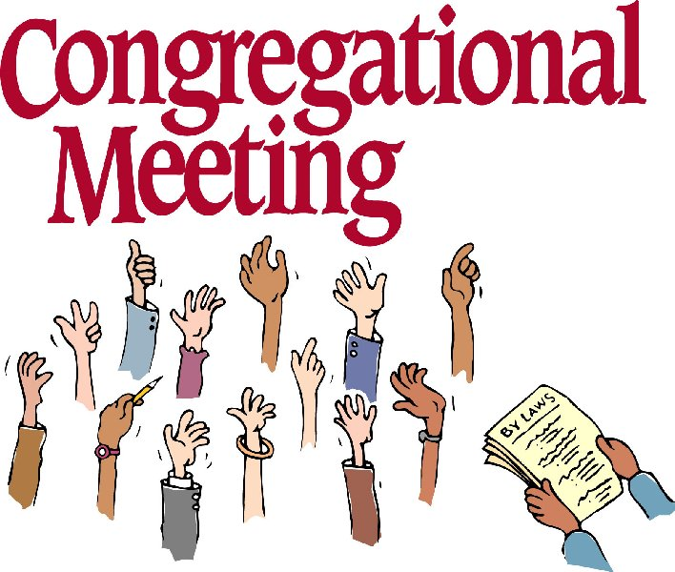
install the new elders, present end of year report and
budget.

Notes

Murray Hill Presbyterian Church



Making His Purpose Count

940 Talbot Avenue
Jacksonville, Florida 32205
(904) 389-2939
www.mhpcjax.com
mhpcjax@gmail.com

Rev. Samuel Bennett

December 28, 2025
December 28, 2025
First Sunday after Christmas

Gathering God’s People

Music for Gathering John Lansdale
Welcome and Announcements Beth Bozeman

*Call To Worship:

Leader: We gather to worship the word made flesh, who fled from the wrath of human powers into Egypt.
People: The God we worship was a refugee.
Leader: We remember the children, from the time of Christ to today, caught in the cross-fires of fear and greed.
People: The God we worship was a refugee.
Leader: We gather to dream and build a better world where all children grow up, all exiles return home.
People: The God we worship was a refugee.

Song of Praise: How Sweet the Name of Jesus Sounds #123
Prayer of the Day

Loving Parent God; Jesus shared our flesh and blood, and we share closeness with you. We thank you for making us your children, a divine chosen family. Make visible to us the ties that bind us to each othere, to all creatures, and to you. Move us to guard each other’s well-being and to treat each other’s struggles as our own, that we may live into the perfect kinship already ours through Jesus our brother, woven together by his Spirit. Amen.

Passing the Peace of Christ:

Leader: May the Peace of Our Risen Christ be with you!
People: And also with you.
(It is our custom to greet one another at this time using the words above)

Song of Adoration (please find your way back to your seat as we sing together):

*G

Glory be to the Father, and to the Son and to the Holy Ghost, as it was in the beginning is now and ever shall be, World without end. Amen. Amen.

Song Of Joy: I Heard the Bells on Christmas Day #267

Pastoral prayer and Lord’s Prayer Rev. Samuel Bennett

Proclaiming the Word of God

Scripture: 2nd Peter 1: 3-9
Message: “Put on Brotherly Kindness” Rev. Samuel Bennett

Responding to God’s Grace

Offering of our gifts and pledges
Offertory Music
*Doxology (Owens Arrangement) #814
Prayer of Dedication Rev. Samuel Bennett

*Sending

*Song of witness: I’d Rather Have Jesus #506
Benediction Rev. Samuel Bennett
Congregational Response: The Family of God # 419
*Please stand for these parts of the service if you are able.

