Week of January 4 - January 11 - 2026
Opportunities for Worship, Service, Study, and Fellowship:

Today: Worship 10:45 am
Social time and Snack after Worship
Open House at Church Fellowship Hall 5:30 pm
Monday: Christian Support Group Fellowship Hall 5:30 pm
Tuesday: Epiphany of the Lord
Wednesday: WSAA Fellowship Hall 7:00 pm
Thursday:
Friday:
Saturday: Workday Church 9 am until 12:30
Lunch (potluck) Fellowship Hall about 12:30 pm
Women’s Meeting Fellowship Hall after Lunch
Sunday: Worship 10:45 am
Potluck Dinner after Worship
Session Meeting after lunch Fellowship Hall
_______________________________________________________________________________

On January 11th we will have a congregational meeting to
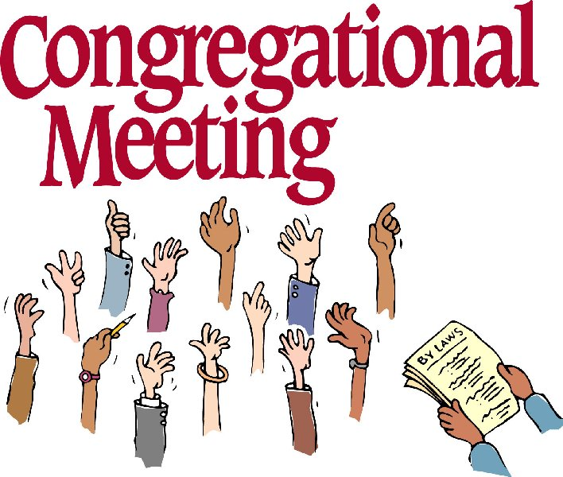
install the new elders, present end of year report and
budget.

Notes

Murray Hill Presbyterian Church



Making His Purpose Count

940 Talbot Avenue
Jacksonville, Florida 32205
(904) 389-2939
www.mhpcjax.com
mhpcjax@gmail.com

Rev. Jesse Bozeman

January 4, 2026
January 4, 2026

Gathering God’s People

Music for Gathering John Lansdale
Welcome and Announcements Rev. Samuel Bennett

*Opening Sentences

Leader: Before the foundation of the world,
People: God destined us for love.
Leader: Through Jesus Christ, the Word made flesh,
People: God adopted us into his own family.
Leader: From the farthest edges of the earth,
People: God shepherds their family home.

*Opening Song: Take My Life and Let It Be Consecrated #597

Prayer of the Day

Eternal Word, you loved us into being, and your love sustains us still. Shepherd us toward your abundant life; teach us to tend to the earth until it blooms. And, when time has reached its fullness, gather us into yourself so that, with you, we may nestle close to the heart of Parent God.

(Observe a time of silence for personal prayers of confession) Amen

Passing the Peace of Christ:

Leader: May the Peace of Our Risen Christ be with you!
People: And also with you.
(It is our custom to greet one another with the Peace of Christ)

Song of Adoration
*Glory be to the Father, and to the Son and to the Holy Ghost, as it was in the beginning is now and ever shall be, World without end. Amen. Amen.

*Song of Worship: Trust and Obey #571

Pastoral prayer and Lord’s Prayer Rev. Jesse Bozeman

Proclaiming the Word of God

Scripture Various Scriptures
Message: “Bygone Days” Rev. Jesse Bozeman

Welcome New Members

Bill and David

Communion
Rev. Jesse Bozeman

Communion Cups in Narthex (We will take communion together)
*Apostles’ Creed – Traditional Inside back cover of hymnal

Responding to God’s Grace

Offering of our gifts and pledges and Communion offering (separate envelope please)
Offertory Music John Lansdale
*Doxology (Owens Arrangement) #814
Prayer of Dedication Rev. Jesse Bozeman

Sending

*Song of witness: I’ll Live for Him #590
Benediction Rev. Jesse Bozeman
Congregational Response: Lord, Dismiss Us with Thy Blessing #237

*Please stand for these parts of the service if you are able.\

